**GENERAL HUMAN BIOLOGY**

**TASK 9 - RAT DISSECTION PRACTICAL**

**NAME: _______________________________________ WEIGHTING: 5%**

**DATE: _______________________________________ MARK: ________ / 25**

This assessment has two parts –

* Information from video **(7 marks)**
* Rat dissection and questions **(18 marks)**

**PART ONE**

Answer the following questions based on the videos your teacher shows you.

1. Why do pregnant female rats have 5 pairs of nipples, according to the video? (1 mark)
2. In the video the teacher separates the muscle from the skin using the blunt side of the scissors. What is the importance of this? (1 mark)
3. As you cut the muscle, you lift it up. Why? (1 mark)
4. The uterus is Y-shaped in the female rat. How is this different to the uterus of a female human?

(1 mark)

1. Do female rats usually have a pregnancy with a single offspring or multiple offspring? (1 mark)
2. What is the benefit of the Y-shaped uterus for a female rat? (2 marks)

**Part Two**

1. Determine if your rat is a male or a female. Males are larger with an obvious scrotum whilst females are smaller and have three opening in the urogenital area.
2. Read your Rat Dissection Protocol CAREFULLY! This will help ensure that you follow it methodically and do not make a mistake.
   * You will be marked on how well your group completes the dissection (4 marks)
3. In the space provided, draw a diagram of your rat’s reproductive system.
   * Include whether it is a male or female
   * Label any structures that have helped you determine this on your diagram.

(3 marks)

1. List any differences that you can see between your rat and the human reproductive system.

(1 mark)

1. Below are diagrams of a dissected male and dissected female rat. Label the reproductive structures for each rate below. (4 marks)

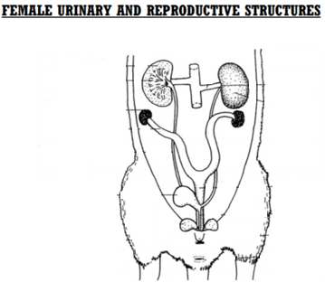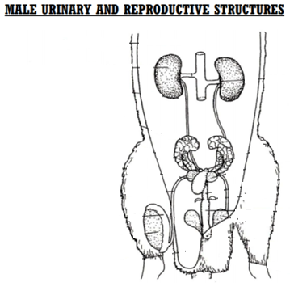

STRUCTURES

Seminal vesicle, Penis, Testes, Scrotum, Prostate gland, Vas deferens. Epididymis, Urethra

STRUCTURES

Vaginal opening, Ovary, Anus, Uterine horns, Vagina

**Rats do not have fallopian tube.

Uterus is called uterine horn.

Below is a diagram showing the development and pathway taken by a zygote after fertilisation has occurred.

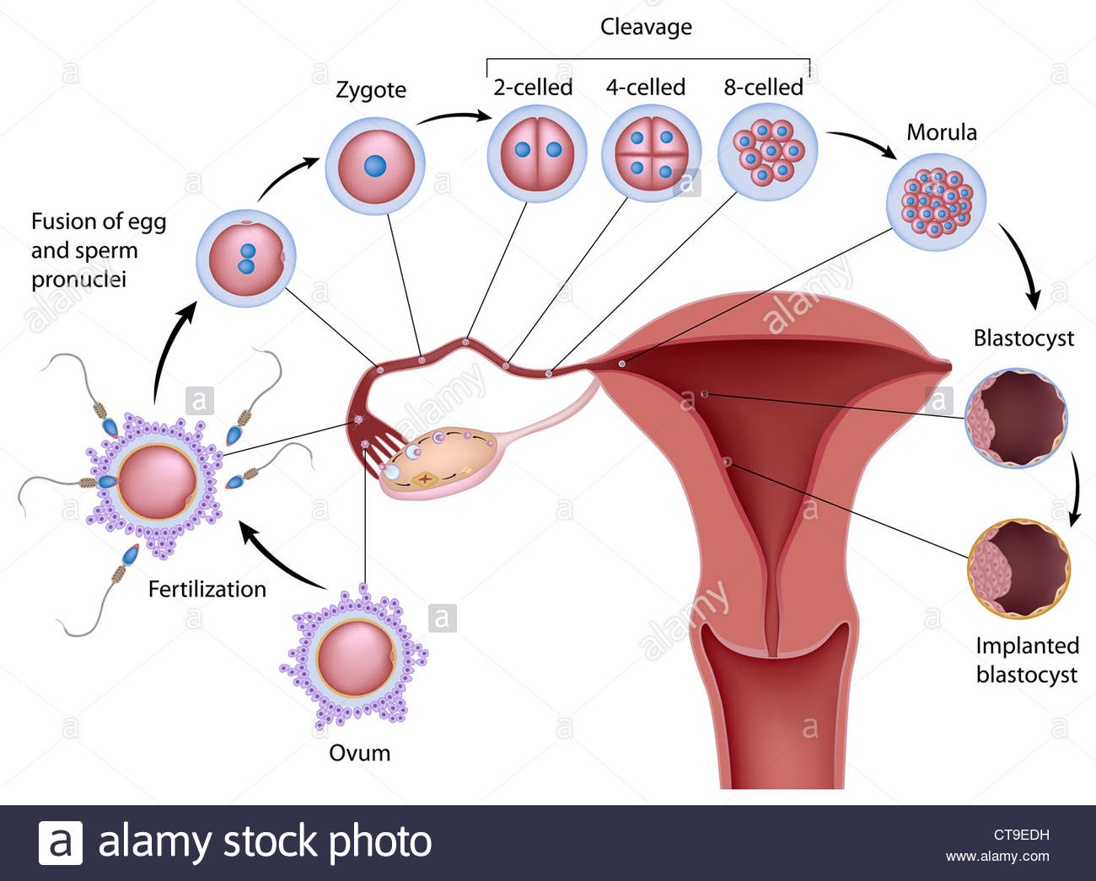

1. What form of cell division does the zygote go through to increase its number of cells and grow?

(1 mark)

1. As a zygote (fertilised egg) continues to develop and mature during pregnancy, the name given to it changes. What are two other names used during pregnancy for the developing unborn child? (2 marks)
2. An ectopic pregnancy is where the fertilised egg does not implant itself into the uterine wall. This results in the pregnancy being terminated either naturally (due to incorrect growing conditions) or by medical intervention. Why would an ectopic pregnancy not allow for the growth and development of a fertilised egg? (3 marks)